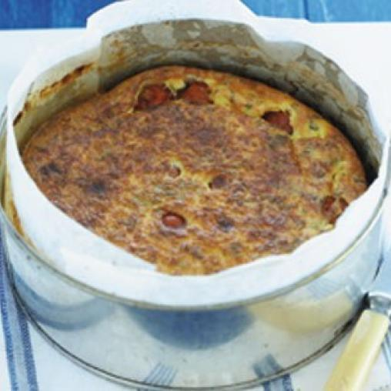
Roast Tomato Frittata
Serves: 4
Time to make: 1 hr 10 mins (Hands-on time: 10 mins, Cooking time: 60 mins)
Total cost: $2.99 / $11.98 per serve
- 250g punnet cherry tomatoes
- 3 eggs
- 3 egg whites
- 200g low-fat ricotta
- 1/2 cup extra-light sour cream
- 2 tablespoons chopped fresh oregano
- 2 cloves garlic, crushed
- 60g baby rocket leaves, to serve
Instructions
Step 1
Preheat oven to 200ºC. Spray a 20cm round cake pan with cooking oil. Line base and side with non-stick baking paper. Place tomatoes in pan. Cook in oven for 10 minutes or until slightly collapsed. Reduce oven to 170°C.
Step 2
Meanwhile, whisk eggs, egg whites, ricotta, sour cream, oregano and garlic until combined.
Step 3
Pour egg mixture over tomatoes and lightly tap pan on bench to spread evenly. Bake for 45 minutes until the frittata is just set. Remove from oven and set aside in pan for 10 minutes.
Step 4
Carefully turn out frittata onto a chopping board. Cut into wedges and serve with rocket.
Nutritional information (per serve)
Kilojoules 750kJ
Calories 179cal
Protein 14g
Total fat 10g
Saturated fat 5g
Carbohydrates 10g
Sugars 5g
Dietary fibre 1g
Gluten ZERO – Gluten Free

http://www.healthyfoodguide.com.au/recipes/2009/november/roast-tomato-frittata

